**Real-Time Health Monitoring Using Wearable Devices**

**Problem Statement**

The increasing acceptance of wearable devices in recent years leads to the fact that a varied range of physiological and functional data are captured continuously by these devices which can be used for real time health monitoring by using these wearable devices. With the help of technology, a wearable device is used for health monitoring using a RNN with LSTM based system. This system will monitor features extracted from wearable sensors, these wearable products will be a motion sensor. The system will classify a patient and inform the patient about its health status.

Five components of this system architecture are Input, Data Processing, Machine Learning, Decision Making and Output. By the help of this type of system and wearable sensor, health monitoring can be done for a patient who is living in remote area because it would be difficult for such patients to regularly visit hospitals or go for checkups on regular basis. So this system can reduce the risk of life and improve the health status of a person. This motion sensor band will use Wireless Medical Telemetry Services (WMTS), unlicensed Industrial Scientific and Medical(ISM), Ultra-wideband (UWB) and Medical Implant Communications Service (MICS) bands for data transmission and will measure pressure, blood sugar, pulse rate, body temp. This system will also make use of body area network (BAN) as an emerging Technology for providing health information. As an expected output of this project some chronical diseases like diabetes, heart diseases can be treat in a better way with proper care which will improve patient’s health.

**Background**

In health-related research using wearables previously technologies like wireless body area network were used. WBAN traffic is categorized into On-demand, Emergency, and traditional traffic Real-time health monitoring using wearable devices uses classification method for time-series analysis. The main challenge is of selecting a suitable set of features for subsequent classification. Previously, ZigBee was also used to communicate between mobile system and physiological devices. Recording the link quality, packet delivery and Received Signal Strength Indicator (RSSI) values in time period is done and then health status is checked.

Recent surveys of research in this field shows that a wide range of internet of things based devices, wearable sensors in the form of watch, band, and cloth are used. Most of the research reports have implemented several routing techniques like ZigBee, Wi-Fi, RFID, Bluetooth for Real time health monitoring used in wearable devices. In this type of research, generally used tools are Striiv Fusion Bio Fitness Tracker, Fitbit Charge HR Fitness Tracker, Garmin vivosmart, HR Fitness Tracker, Smart Shoes, Smart Jacket, and smart Gloves.

**Methodology**

**Step 1: Data collection and dataset preparation**

This will involve collection of physiological signals measured using wearable devices that contains motion sensors then the input data must be processed into a set of features before becoming suitable inputs for RNN based system. Preprocessing is applied on dataset processing by noise reduction, feature extraction and data normalization.

**Step 2: Developing a Machine Learning Algorithm (RNN with LSTM) for health monitoring**

In this step a machine learning algorithm RNN is designed for the calculation of a decision regarding patient health status. The RNN is chosen because of its ability to construct a robust classifier because the data which will be generated is in time series form. In addition, it has good generalization properties allowing it to classify new data that is coming continuously.

**Step 3: Training and experimentation on datasets**

The health monitoring model that is machine learning algorithm will be trained on the dataset to do the monitoring of health accurately and notify the patient.

**Step 4: Deployment and analysis on real life scenario**

**INPUT**-

Signal Data Obtained from Wearable Device

**Decision making-**Local display, Binary Risk Analysis

**Machine learning Implementation**-RNN with LSTM

**Data Preprocessing-**Feature Extraction

**OUTPUT-**

Transmit and Store and Display

v

Figure.1 The proposed system architecture for real-time health monitoring using wearable devices.

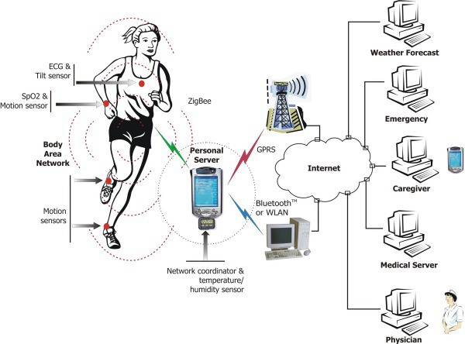

# Figure.2 System architecture of proposed approach[1]

The trained and tested health monitoring model will be deployed in a real-life scenario made by the human experts & will be leveraged for further improvement in the methodology and will follow the above architecture.it will also follows the proposed architecture where the wearable device is also shown and its working is explained with the help of diagram.

**Experimental Design**

*Dataset*

ActiveMiles is the dataset[2], which contains unconstrained real world human activity data from 10 subjects collected using five different smartphones complex real-world activity data, collected from multiple users will be used for experimentation and evaluation**.**

*Evaluation Measures*

Measures such as Computation time, Body Mass Index, Accuracy, precision recall and comparison with other already present models also the technique which will consume low power will be measured and evaluation is done for real-time health monitoring using wearable devices.

**Software and Hardware Requirements**

Python based Deep Learning libraries will be exploited for the development and experimentation of the project. Android devices (Smartphone) is needed and as an embedded algorithm for the Intel Edison Development Platform is to be installed the app is available at Google Play store[3]. Tools such as Anaconda Python, and some python libraries will be utilized for this process. Training will be conducted on NVIDIA GPUs for training the above proposed system for real time health monitoring using wearable devices like Smart band for hand and legs.

1. [<https://vladlenovsjannikov.wordpress.com/>cети
2. http://hamlyn.doc.ic.ac.uk/activemiles/
3. https://play.google.com/store/apps/details?id=org.imperial.activemilespro